Product Introduction

1.1 Introduction
It complies with standards such as IEEE 802.3ah and YD/T 1475 - 2006, has good interoperability and operability, and can be interconnected with mainstream OLT devices.
It provides one PON port for uplink, and can cooperate with OLT and ODN to build a GPON system, enabling FTTH.

1.2 Product Features
- It adopts a point - to - multi - point topology to converge users' Gigabit services. It provides standard RJ45 interfaces, supports 802.3af and 802.3at standard PSE power supply, and can be smoothly interconnected with existing networks.
- It has a dynamic bandwidth allocation mechanism to ensure QoS.
- It supports IGMP and VLAN multicast to make use of the broadband.
- It supports Gigabit loop detection and automatic recovery, and also supports remote loopback for network diagnosis.
- It has rich OAM functions and supports both remote and local management.
1.3 Product Appearance:
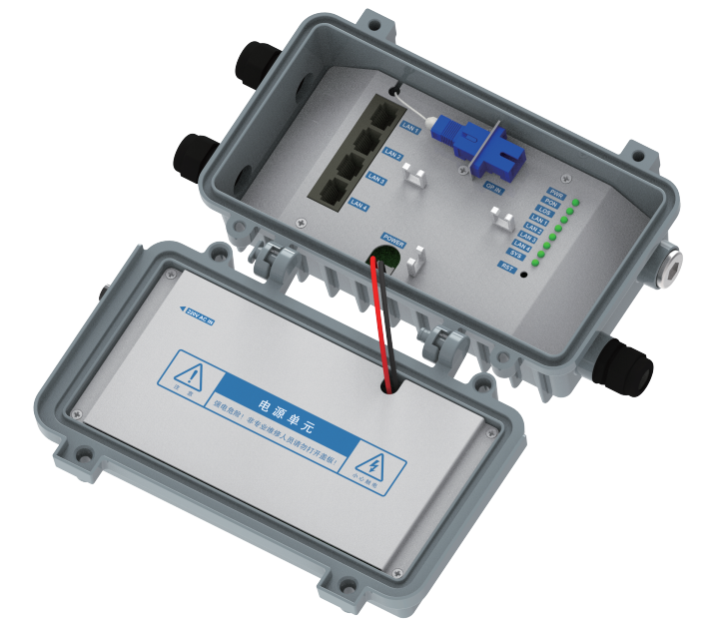
1.4 Indicator Explanation
Indicator | Status | Explanation
POWER | On | Power is on
POWER | Off | Power is off
PON | On | ONU link is activated
PON | Blinking | ONU is trying to establish a connection
PON | Off | Received optical power is lower than the optical reception sensitivity
LOS | On | ONU has no optical signal access
LOS | Off | ONU receives normal optical power
LAN1—LAN4 | On | The network port is connected, but there is no data transmission
LAN1—LAN4 | Blinking | There is data transmission on the network port
LAN1—LAN4 | Off | ONU is not powered on or the network cable is not connected
SYSTEM | On | Connected to the external network
SYSTEM | Off | Not connected to the network

1.5 Interface Explanation
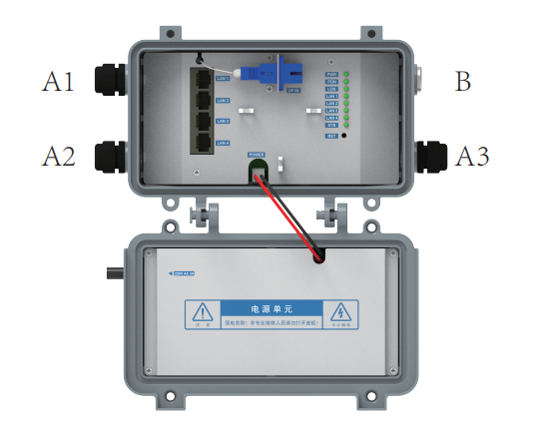
Interface | Quantity | Description | Purpose
LAN1—LAN4 | 4 | RJ45, 10/100/1000Base - TX | Connect to customer - side devices
OP IN | 1 | SC/PC | Connect single - mode optical fiber to ODN
RST Button | 1 | Hidden | Reset. Long - press to restore factory settings
A1, A2, A3 | 3 | Water - proof connectors | For network cable access
B | 1 | Optical fiber interface | For optical fiber access

Technical Specifications and Parameters
2.1 Technical Specifications
Item | Description
Power Supply | 220V AC
Power Consumption | <6W
Dimensions (Length × Width × Height) | 190mm×130mm×95mm
Weight | <1Kg (body)
Storage Temperature | -40°C - 80°C
Storage Humidity | 5% - 95% (non - condensing)
Operating Temperature | 0°C - 60°C
Operating Humidity | 5% - 95% (non - condensing)
Atmospheric Pressure | 62kPa - 106kPa
Dust - proof Requirement | Meet the requirements of YD/T1475 - 2006
Dielectric Withstand Voltage | L&N to Protective Earth: 1500Vac; L&N to Gigabit Port: 3000Vac
Over - current and Over - voltage Protection for Power Supply | Available
Lightning Protection | Power Port: ±2.5KV (common mode); ±2.5KV (differential mode); Gigabit Port: ±1.5KV (common mode)
EMC | Comply with the regulations of GB 9254 - 1998 and GB/T17618 - 1998
MTBF | 50,000 hours
Installation Method | Network cabinet/wall - mounted
2.2 Standards Followed:
- Support the 《GPON Equipment Interoperability Requirements》, meet all extended OAM functions
- Comply with standards such as 《Access Network Technical Requirements - Gigabit - based Passive Optical Network (GPON)》,
- IEEE802.3ah
- IEEE802.3
- IEEE802.3x
- IEEE802.1p priority
- IEEE802.1q VLAN

Configuration Cases
  - User Requirements
FTTH, ability to connect to the Internet, and ability to watch TV via on - demand services.
3.2 Network Diagram
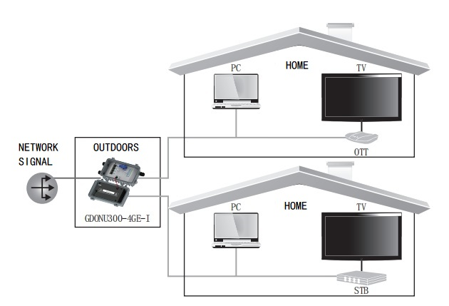

Common Fault Troubleshooting
Q1： How should I set up TCP/IP to connect my computer to a device？
The default IP address of the device is 192.168.0.100. The computer's IP address should be set between 192.168.0.2 and 192.168.0.254, and the subnet mask should be 255.255.255.0.
Q2：How can I confirm that my computer has successfully connected to the device?
Use the "Ping 192.168.0.100" command in the command prompt. If there is a connection problem, it will show "connection timed out".
Q3：Does the device have the function of restoring factory settings?
Press and hold the reset button (marked RST) for more than 5 seconds, and the device will restart and restore to factory settings.
Q4：Does the PON link indicator light of the device always display as off?
If the PON link indicator is off, it means the link has not been successfully established. Check whether the optical fiber is firmly inserted, the connection is correct, and whether the pigtail is bent. If there is no problem, check with the central office whether there is a problem with the OLT's PON service board.

