


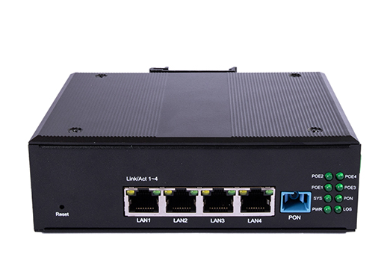

Features: --------------------------------------
- Compliance with IEEE 802.3ah(EPON) & ITU-T
G.984.x(GPON) standard
- Support Layer 2 802.1Q VLAN, 802.1P QoS
- Support IGMP V2 snooping
- Support lightning protection of up to 4 kV
- Support port loop detection
- Support port rate limit
- Support hardware watchdog
- Support bi-directional FEC
- Support dynamic bandwidth allocation function
- Support LED indication
- Support remote upgrade by olt and web
- Support factory settings restore
- Support remote reset and reboot
- Support dying gasp outage alarm
- Support data encryption and decryption
- Support sending device alarm to OLT
- supports docking compatibility with various OLT

XPN224G-DP
XPON SFU 4GE+POE
Product introduction

XPN224G-DP provides industrial-grade
high-reliability ONU. By optimizing software and hardware processing, it supports lightning protection of up to 4 kV and high temperature resistance of up to 70 degrees, and supports docking compatibility with OLT of various manufacturers. What’s more, it supports the selection of POE power supply function, facilitates the deployment of POE monitoring probes, supports Gigabit ports, and ensures smooth transmission under large burst video traffic. The metal shell has good field adaptability while ensuring heat dissipation.

Highlights: --------------------------------------
- Support docking compatibility with OLT of various manufacturers
- Support automatically adapt to the EPON or GPON mode used by the peer OLT
- Support port loop detection and rate limit
- Support lightning protection of up to 4 kV and high temperature resistance of up to 70 degrees
- Support power over ethernet function of port

Hardware Specifications:---------------
- interface: 1* G/EPON+4*GE(POE)
- Power adapter input: 100V-240V AC, 50Hz-60Hz
- Power Supply: DC 50-57V
- Indicator light: SYSTEM/POWER/PON/LOS/
POE1/ POE2 / POE3/ POE4
- Button: Power switch Button, Reset Button
- Power Consumption: < 6W
- Working temperature: -30℃～+75℃
- Environment humidity: 5% ~ 95%
(non-condensing)
- Dimension：137 mm(D)× 105mm(W)× 42mm(H)
(L×W×H)
- Net Weight：0.5Kg

PON Interface: ---------------------------------
- Interface Type: SC/UPC, CLASS B+
- Transmission distance: 0～20km
- Working wavelength:
Up 1310nm；
Down 1490nm；
- RX Optical power sensitivity: -27dBm
- Transmission rate:
GPON: Up 1.244Gbps；Down 2.488Gbps
EPON: Up 1.244Gbps；Down 1.244Gbps

Ethernet Interface : ----------------------
- Interface type：4* RJ45
- Interface parameters：10/100/1000BASE-T
POE



Packing list: --------------------------------

- ONU * 1 PC
- Network cable *1 PC
- Box *1 PC

Packing size: -------------------------------
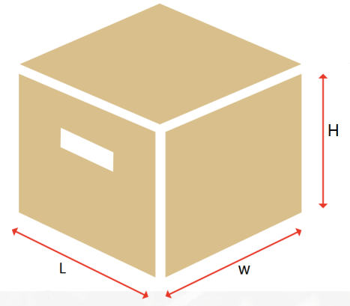

Measurement: 18.7* 13.5 * 80 cm, 0.62kg

Interface and Button: ------------------------------------------------------------------------------
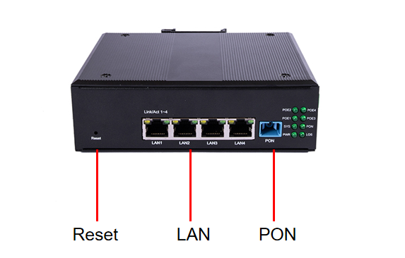
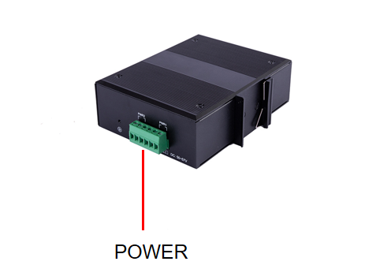
Application Scenario: ---------------------------------------------------------------------------

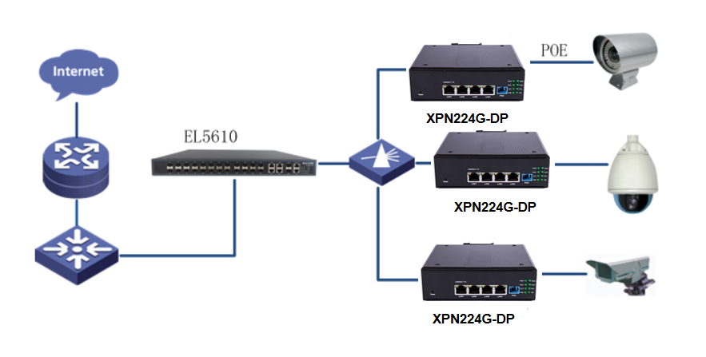

Company Introduction: --------------------------------------------------------------------------
Established in 2016, Shenzhen Huanhu Technology Co., Ltd is a R&D oriented new high-tech enterprise specializing in the production and sales of passive optical network communication products and voice gateway products. As the original manufacturer, Huanhu contributes its own strength to the network access of China and the world.

Since its establishment, Huanhu has been adhering to the management policy of "innovation drives development, quality casts brand", and has been growing rapidly at a rate of nearly 50% annually for the past four years.

Huanhu owns its own processing and manufacturing production lines, a number of SMT lines, wave soldering lines, latter soldering lines and assembly and testing lines, which can provide customers with high quality OEM/ODM services. In recent years, Huanhu has introduced a series of advanced equipment including laser automatic coupling machine, eye diagram instrument, oscilloscope. In addition, Huanhu has obtained ROHS, SGS, TUV certificates. Huanhu has absolute market share in China and also good sales and popularity overseas.

Huanhu combines R&D with manufacturing, firmly grasp the supply chain, aiming to provide customers with fast, high quality, high competitiveness of products and services.

Contact Address: ----------------------------------------------------------------------------------

7 / F, building C4, Hengfeng Industrial City, 739 Zhoushi Road, Hezhou community, Hangcheng street, Bao'an District, Shenzhen

Website: ---------------------------------------------------------------------------------------------

http://www.dualbandonu.com

