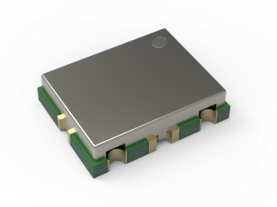
Features
- Standard Frequency Range：205～380MHz@VT=0V～5V
- Output Power：≥10dBm @VCC=5V
- Ripple(BW≤200MHz)：±0.5dB
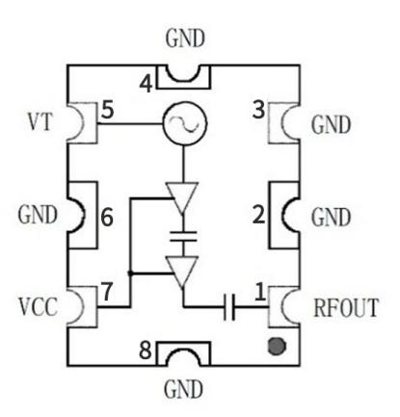
- Supply Voltage(VCC)：4.2V～6V
- Supply Current：16mA@VCC=5V
- Harmonic Suppression(2nd)：≤-10dBc
- Harmonic Suppression(3rd)：≤-15dBc
- No External Components Needed
- 50Ω Load Impedance
- 7mm×9mm×2mm SMT Package

Product Description
The YSGM20038010 voltage-controlled oscillator (VCO) employs a highly stable oscillation circuit design ,delivering high output power and superior isolation. It is powered by a standard 5V supply, with compatibility across a 4.2 to 6V range.Featuring an extensive tuning voltage span of 0-5V, it facilitates broadband frequency output. The built-in filter and impedance matching circuit minimizes the need for external components while ensuring consistent output power stability. The oscillator's output is readily connectable to a 50Ω load. Encased in a compact 7mm×9mm×2mm package, the device is designed for ease of integration and space efficiency.
Pin Description
Pin | Symbol | Function | Pin | Symbol | Function
1 | RFOUT | RF output | 5 | VT | Tune voltage
2 | GND | Ground | 6 | GND | Ground
3 | GND | Ground | 7 | VCC | Supply voltage
4 | GND | Ground | 8 | GND | Ground

Absolute Maximum Ratings
Parameter | Rating | Unit | Parameter | Rating | Unit
Tune Voltage | 0 ~ 5 | V | Storage Temperature | -40 ~ +150 | °C
Supply Voltage | 4.2~ 6 | V | Relative Humidity | ＜80% | RH
Operating Ambient Temperature | -40 ~ +85 | °C | Atmospheric Pressure | 85 ~ 106 | KPa
Specification |  |  |  | Unit | Condition
Specification | Min. | Typ. | Max. | Unit | Condition
Lower Frequency | 200 | 205 | 210 | MHz | VT=0V
Upper Frequency | 375 | 380 | 385 | MHz | VT=5V
Power Output |  | +10 |  | dBm | VCC=5V
Tune Voltage | 0 |  | 5 | V
Supply Current |  | 16 |  | mA | Open&Load
Leakage Current(VT) |  |  | 10 | μA | VT=5V
Pushing（VCC） |  | 3 |  | MHz/V | VT=5V
Pulling（VSWR） |  | 3 |  | MHz pp | VSWR=3:1
Drift Rate |  | 0.04 | 0.06 | MHz/°C
Load Impedance |  | 50 |  | Ω
Harmonic(2nd) |  |  | -10 | dBc
Harmonic(3rd) |  |  | -15 | dBc
Electrical Specifications（T=+25°C，VCC=5V）

Typical Performance
Frequency vs. Tuning Voltage vs. Operating Voltage | Frequency vs. Tuning Voltage vs. Temperature
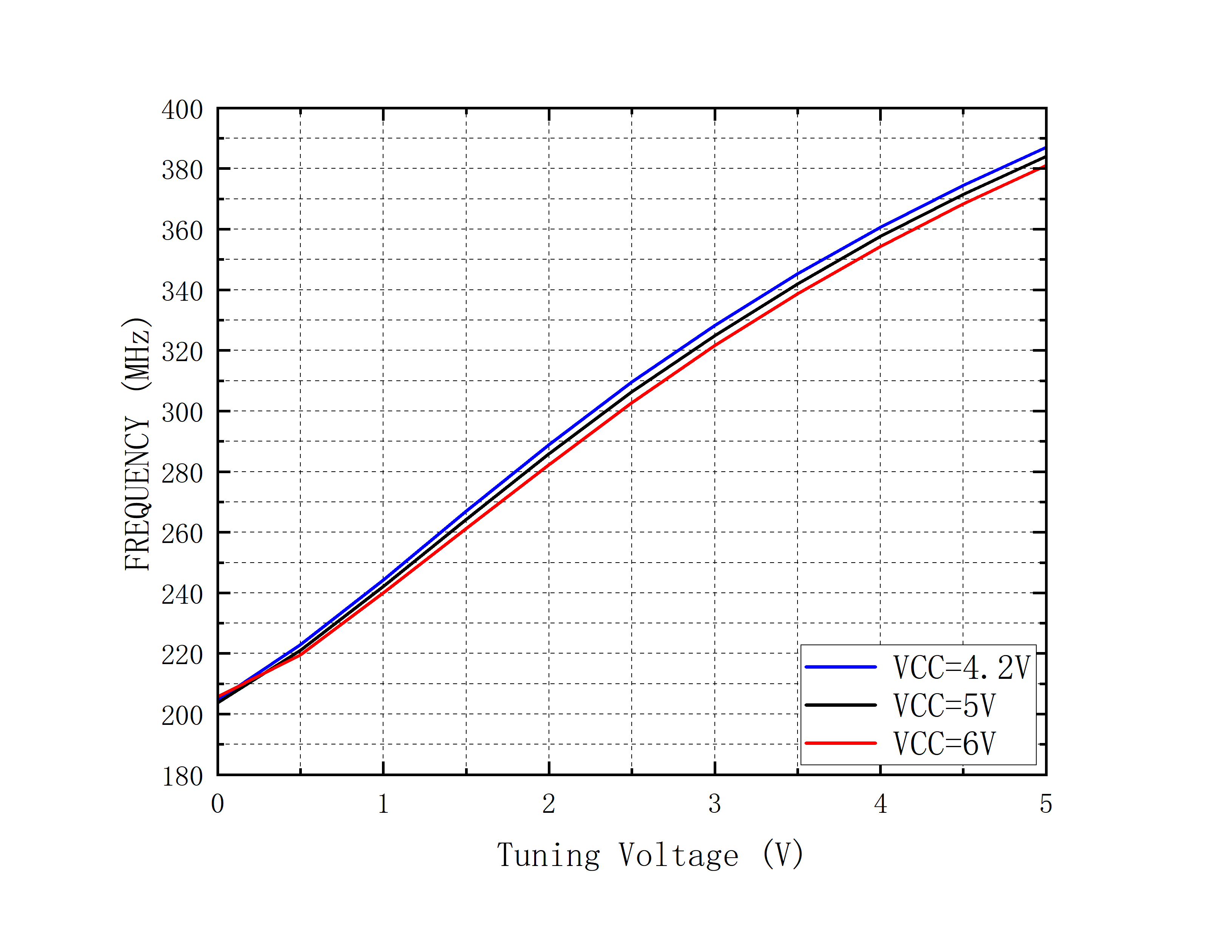 | 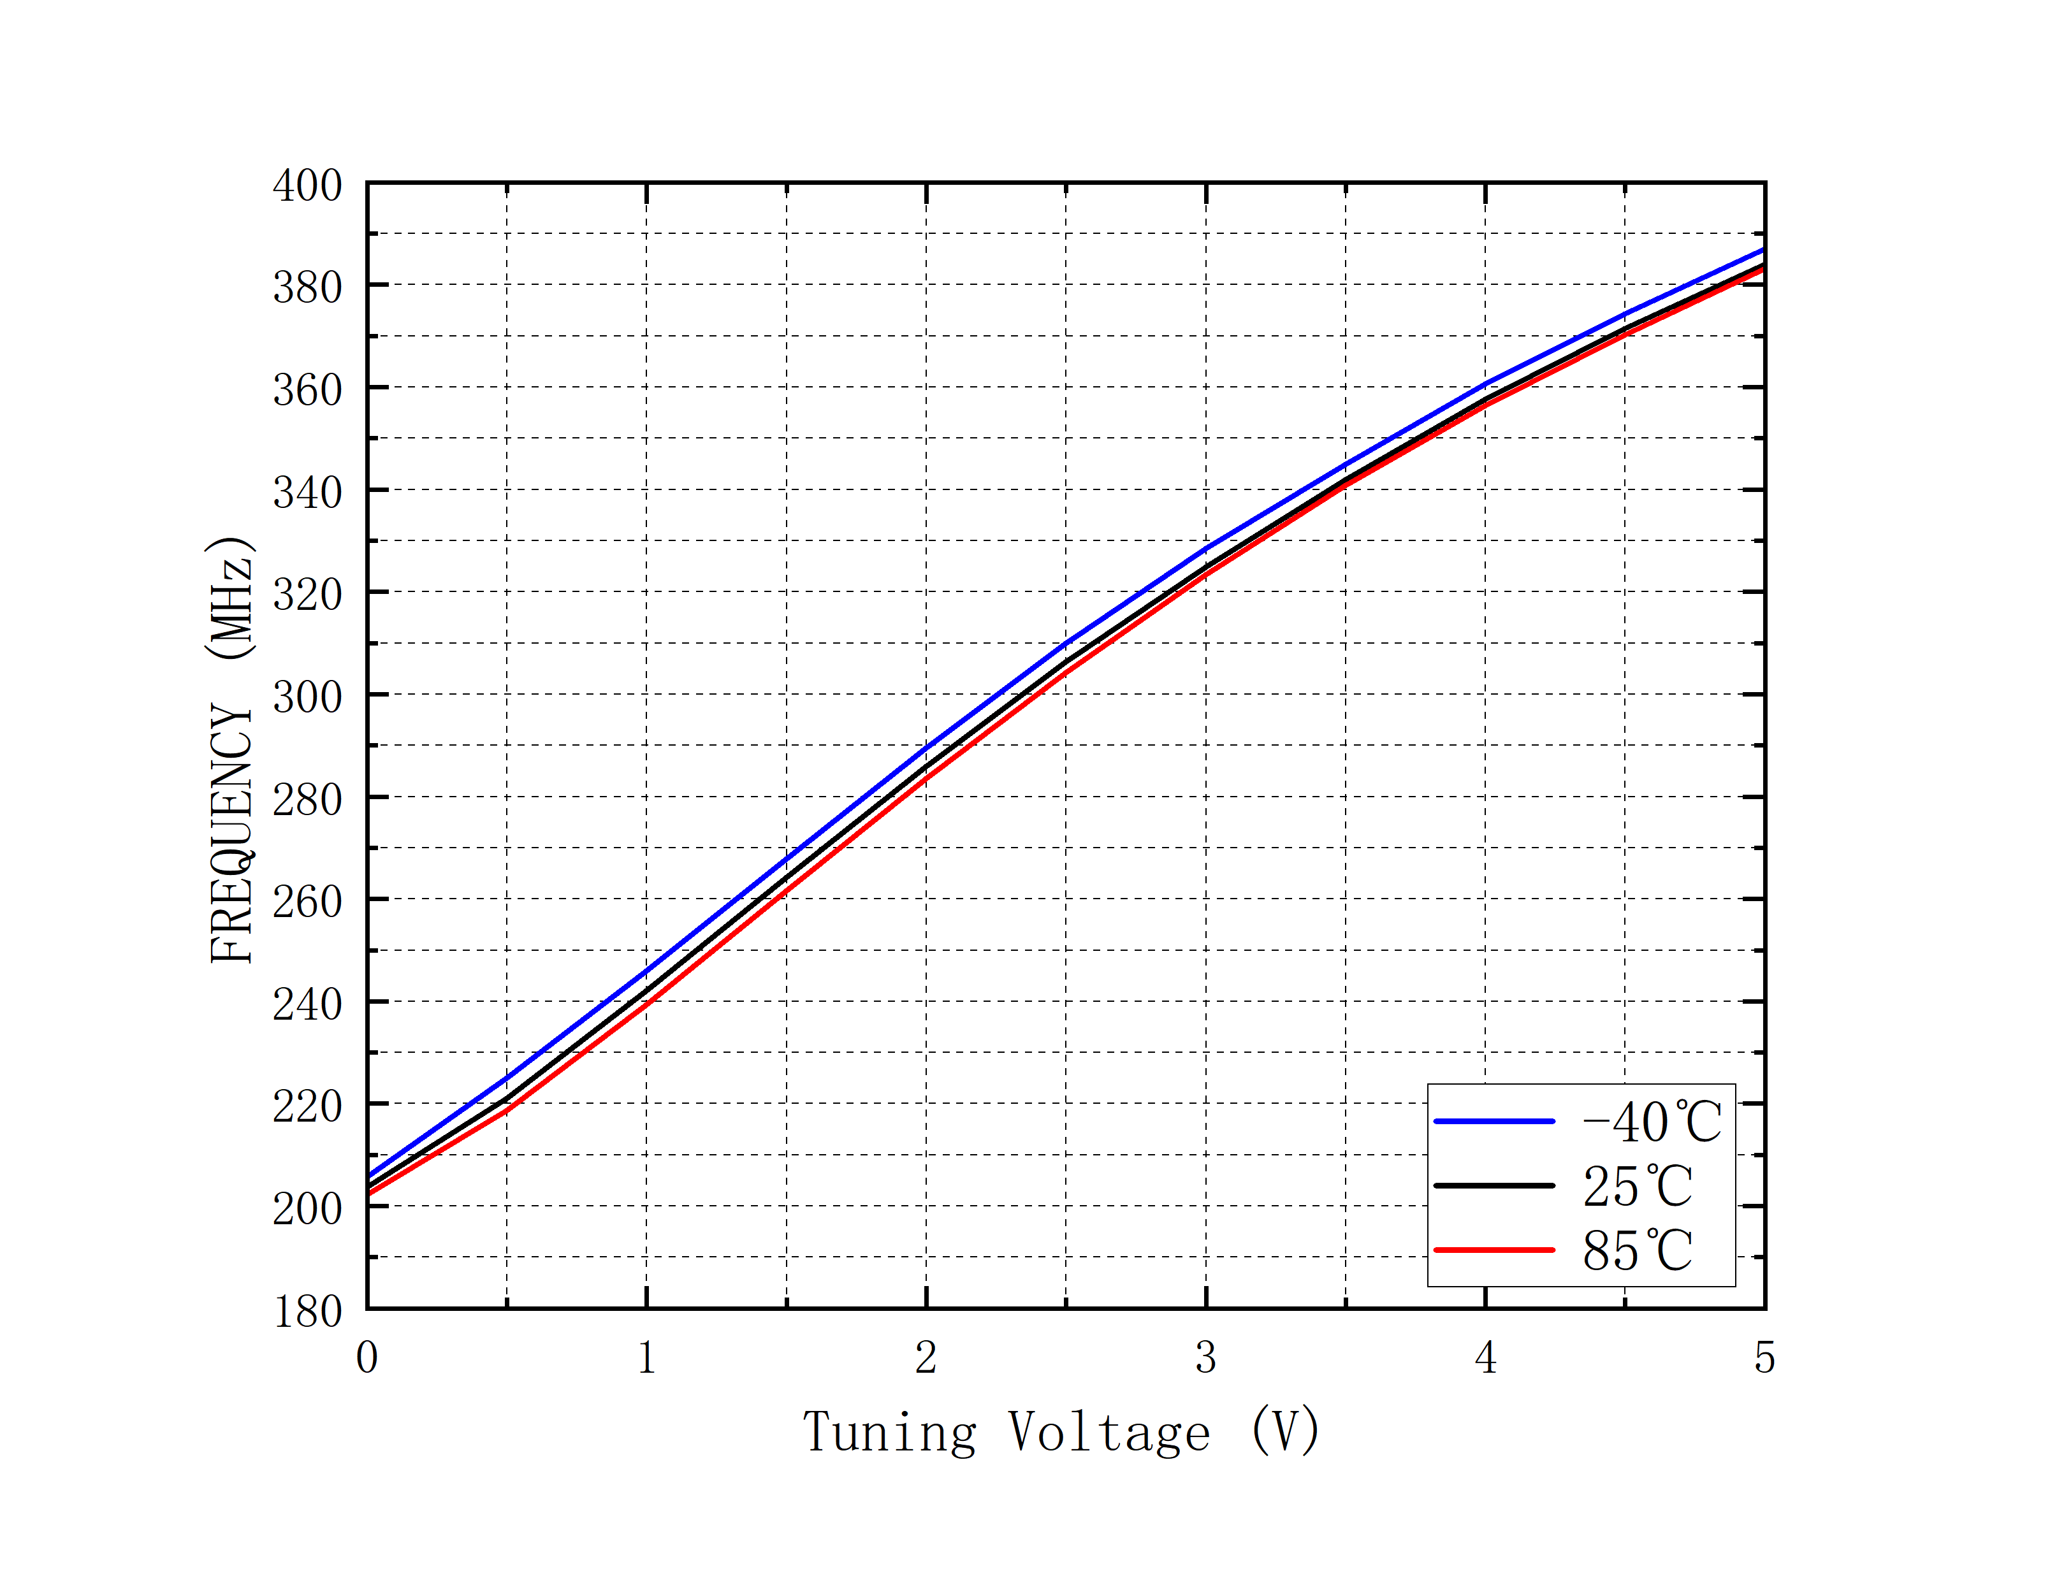
Power vs. Tuning Voltage vs. Operating Voltage | Power vs. Tuning Voltage vs. Temperature
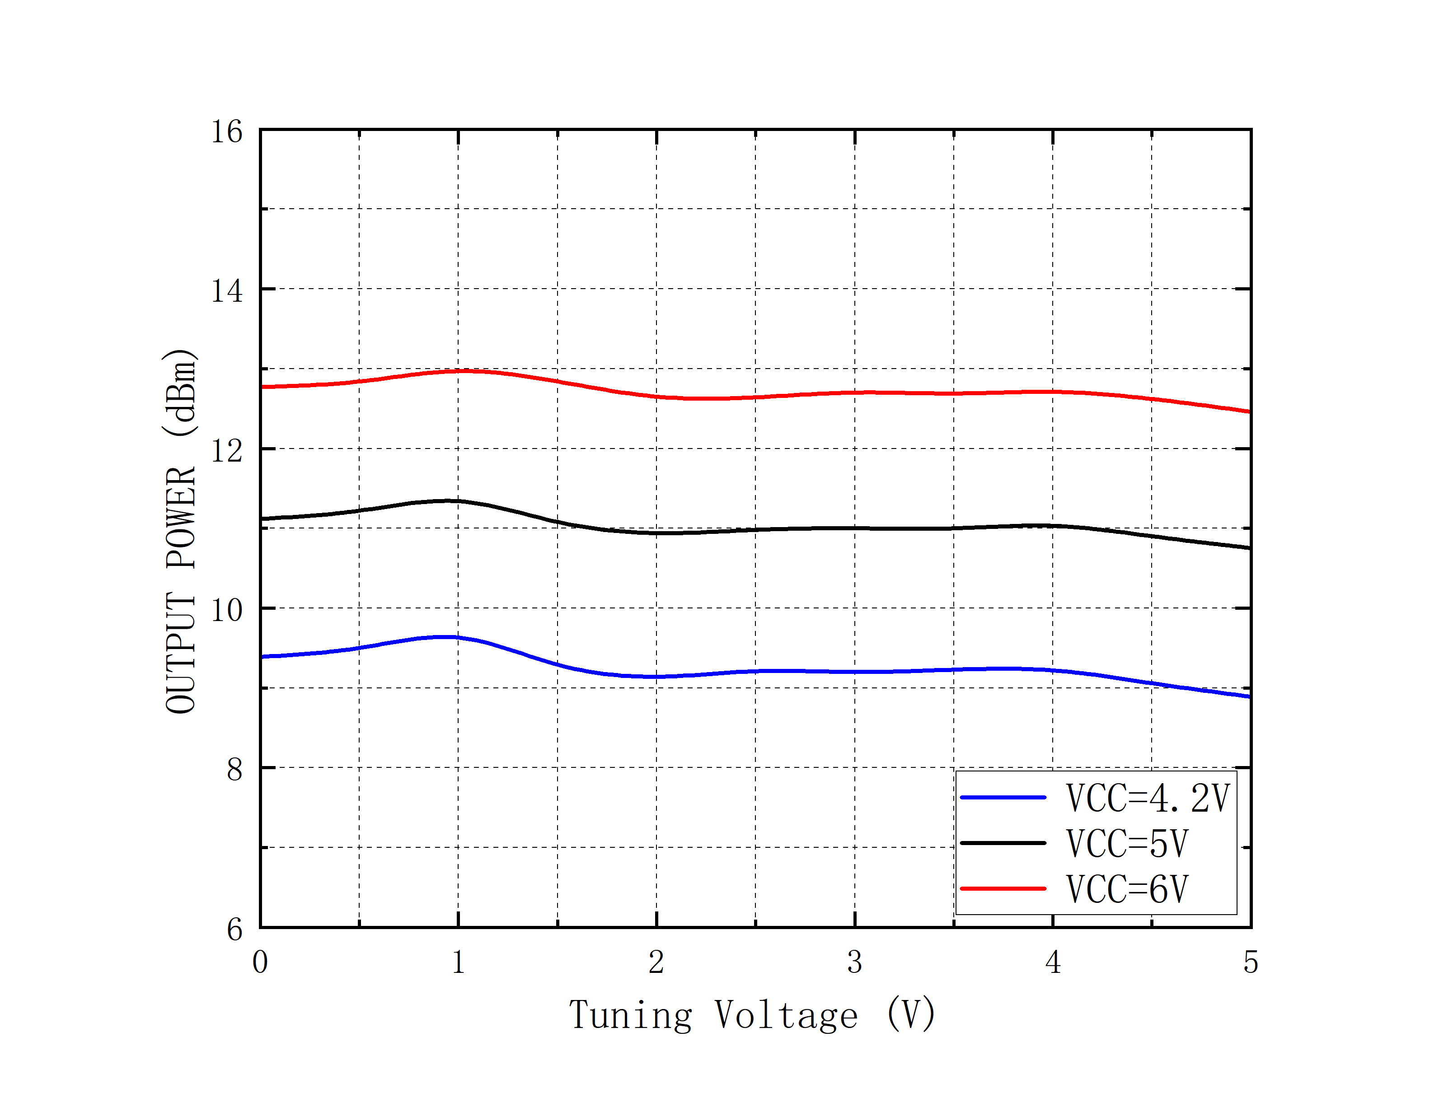 | 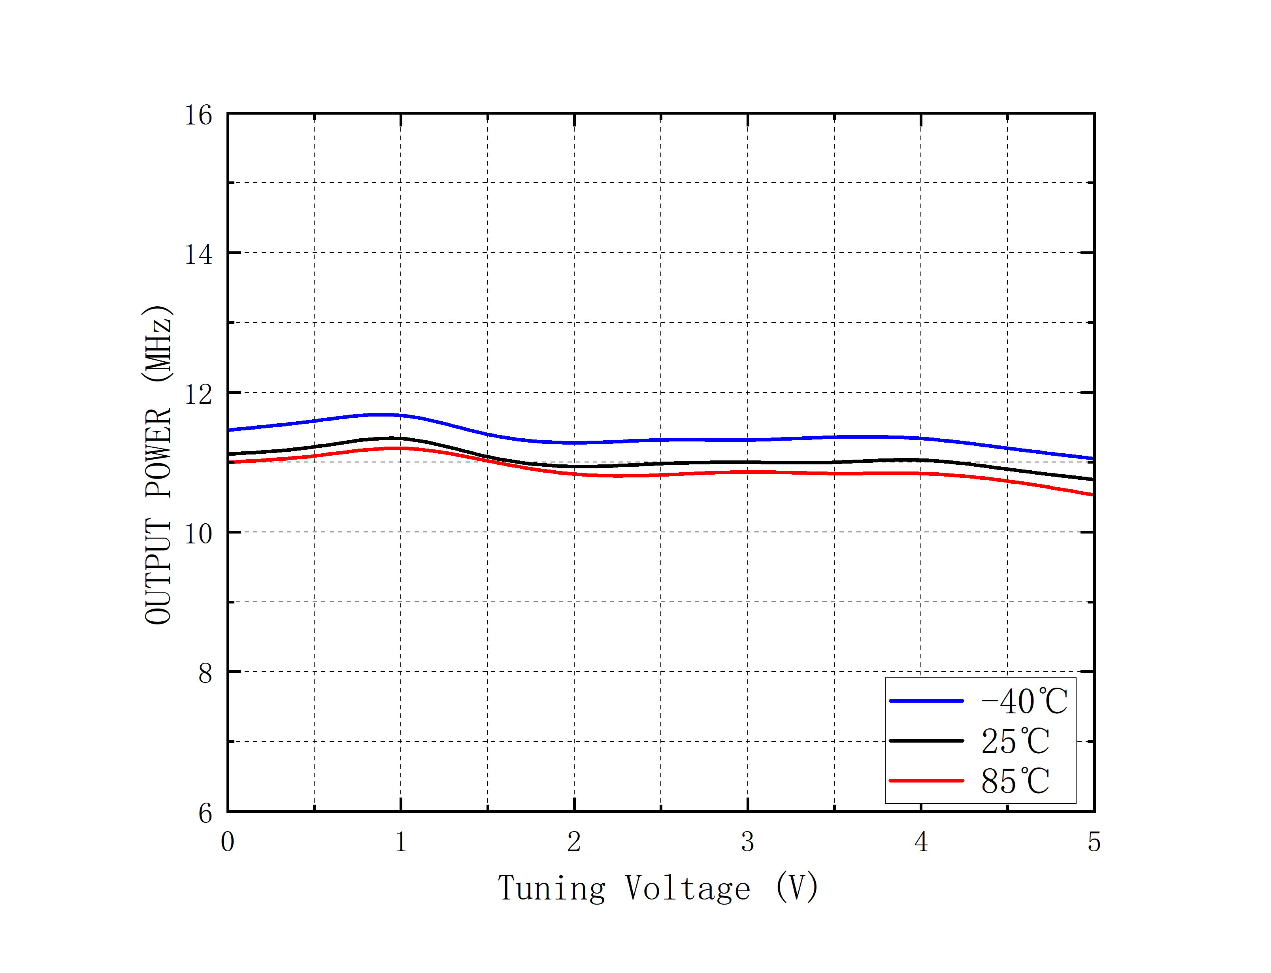

Outline Drawing
TOP VIEW SIDE VIEW
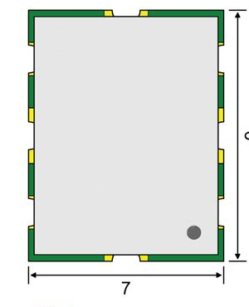

BOTTOM VIEW

UNIT: mm
TOLERANCE: ±0.1mm
PCB Land Pattern

UNIT: mm

