**4x3 HDMI KVM Switch**

**#HKS0403A1U**

HDMI KVM Switch can easily integrate cross-platform computer devices and greatly simplify the devices management. Support managing a triple-display multimedia workstation. If you connect 3 HDMI ports of the same PC to one group of input ports on the KVM, you will realize 3-screen extended display or copy display. It has the same effect as connecting the PC directly to 3 displays. The KVM also supports displaying different PCs on 3 monitors.

This KVM supports using USB hubs and USB keyboard and mouse. It also supports locking L/R audio and USB 2.0 devices to a fixed PC. Support several switching modes. You can switch input ports with front panel keypad, IR signals, keyboard hot keys and RS232 commands. At the same time, with EDID emulators in each input port, it can keep PCs always having correct display information.

**Features:**

* Using 3 monitors, 1 set of keyboard and mouse to control 4 computers
* Support resolution up to 3840x2160@60Hz 4:4:4
* HDMI 2.0 compliant
* HDCP 2.2 compliant
* Support HDR 10 and Dolby Vision
* Support 2 display modes
* Support Unix/Windows/ Debian/ Ubuntu/Fedora/ MacOS X/ Raspbian/ Ubuntu for Raspberry Pi and other Linux based systems
* Support L/R audio output
* Support locking L/R audio and USB 2.0 devices to a fixed PC
* With EDID emulators in each input port, it can keep PCs always having correct display information
* Support function settings on the front panel which can switch ports, turn on/off auto scan, change hot key trigger, lock audio and USB 2.0 and other functions
* Support keyboard and mouse pass through mode to improve mouse and keyboard compatibility
* Support IR signals, front panel buttons, keyboard hot keys and RS232 commands to switch input ports

**Packing List:**

1 * 4x3 HDMI KVM Switch

4 * KVM Cables

8 * HDMI Cables

1 * IR Remote Control

1 * IR Extension Cable

1 * 3 Pins Connector (For RS232)

1 * DC 12V Power Adapter

1 * User Manual

2 * Rack-ears

**Panel Description:**

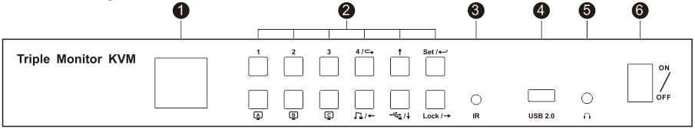

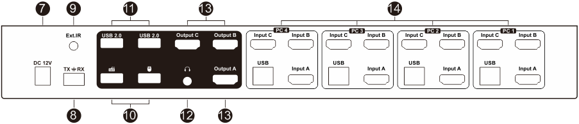

|  |  |  |
| --- | --- | --- |
| **ID** | **Name** | **Description** |
| 1 | Color LCD | Display current status and function settings. |
| 2 | Keypad | Press to control the KVM. |
| 3 | IR receiver | Receive IR remote signal. |
| 4 | USB 2.0 port | Connect to USB 2.0 device. |
| 5 | L/R out | Connect to L/R output device. |
| 6 | Power switch | Turn on or turn off power supply. |
| 7 | DC 12V | 12V DC power supply. |
| 8 | RS232 port | Connect RS232 cable to use RS232 commands to control the Switch. |
| 9 | IR extension in | Connect IR extension cable to this port to receive IR signal even the KVM is installed in a rack. |
| 10 | Keyboard and mouse input | For USB keyboard and mouse input. |
| 11 | USB 2.0 ports | Connect to USB 2.0 devices. |
| 12 | L/R out | Connect to L/R output device. |
| 13 | HDMI outputs | Connect to 3 HDMI displays for video output. |
| 14 | KVM input ports group | 4 PCs can be connected to the KVM at the same time.  Each group contains 3 HDMI ports(marked as Input A/B/C) and a USB port. Connect the ports to corresponding input devices for signal input. |

**Connection Diagram**

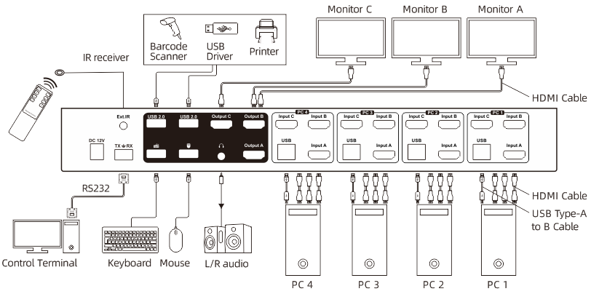

**Specification:**

|  |  |  |
| --- | --- | --- |
| **HKS0403A1U** | **4x3 HDMI KVM Switch** | |
| **Functionality:** | | |
| Auto Scan | Yes | |
| Port selection | Front panel buttons | Yes |
| Keyboard hotkeys | Yes |
| IR remote control | Yes |
| Console commands | RS232 |
| **Technical:** | | |
| Resolution | Up to 3840x2160@60Hz 4:4:4 | |
| Auto to get EDID | Yes | |
| Data rate | 18 Gbps | |
| Auto scan interval | 1~3600 Seconds | |
| OSD | No | |
| Supported OS | Unix/Windows/Debian /Ubuntu /Fedora /Mac OS X/ Raspbian /Ubuntu for Raspberry Pi and other Linux based system | |
| Console ports | Keyboard emulation | 1 * USB Type A |
| Mouse emulation | 1 * USB Type A |
| USB 2.0 Hub ports | 2 * USB Type A |
| Video /Audio | 12 * HDMI Type A |
| System ports | USB Data | 4 * USB Type B |
| L/R Audio output | 1 * AUX |
| Video / Audio | 3 * HDMI Type A |
| Ext.IR | 1 * AUX |
| RS232 | 3 Pins jack |
| ESD protection | Human body model - ±8kV (Air-gap discharge) | |
| **Mechanical:** | | |
| Chasing material | Aluminum Alloy | |
| Product dimensions | 350 (L) x 149 (W) x 44.5(H) mm | |
| Item weight | 1700g | |