**Circular tube horizontal scraping linkage**

It is suitable for bus models with wide body ,and can be designed and matched according to the front size or three-dimensional data provided by customers.

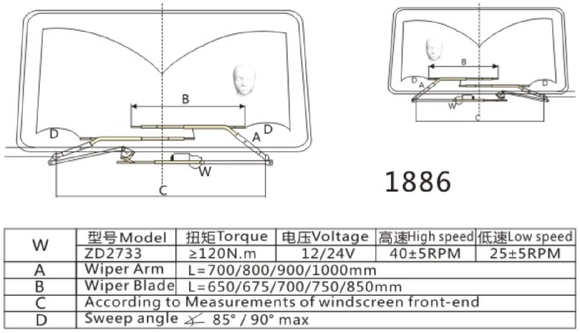

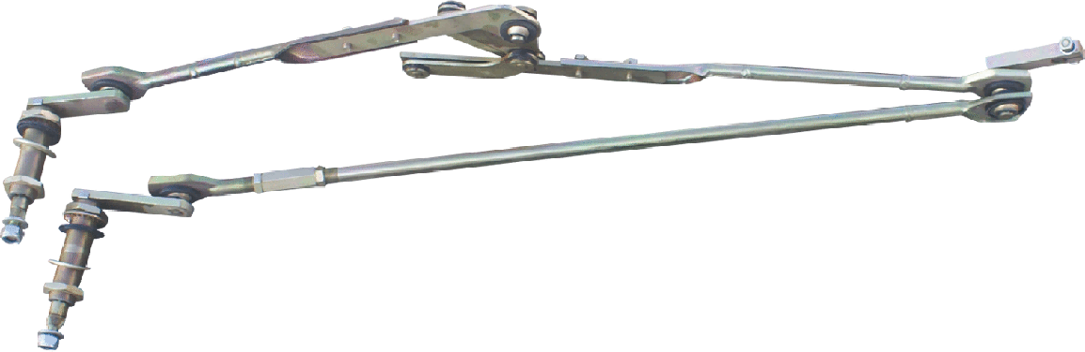

**Horizontal channel scraping linkage**

It is suitable for bus models with wide body ,and can be designed and matched according to the front size or three-dimensional data provided by customers.

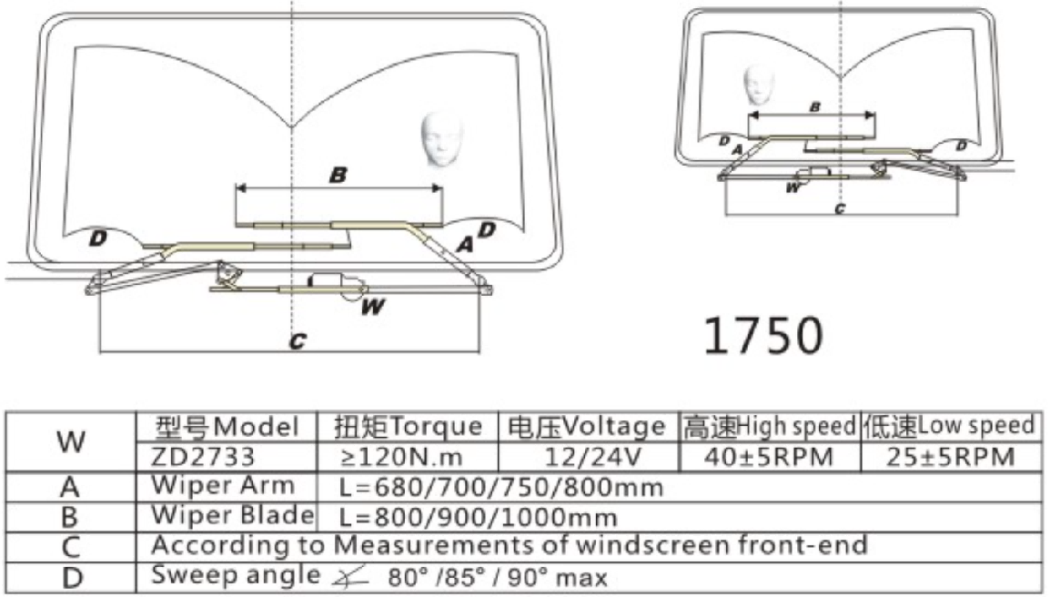

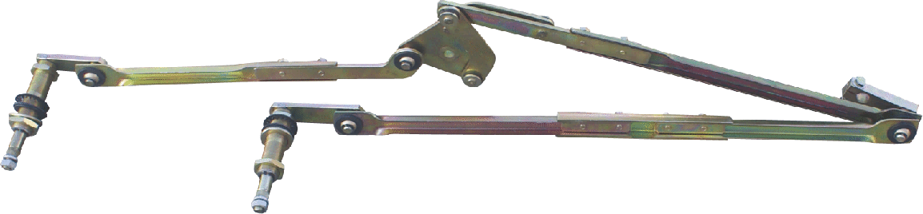

**Channel steel vertical double linkage**

Suitable for buses with two front

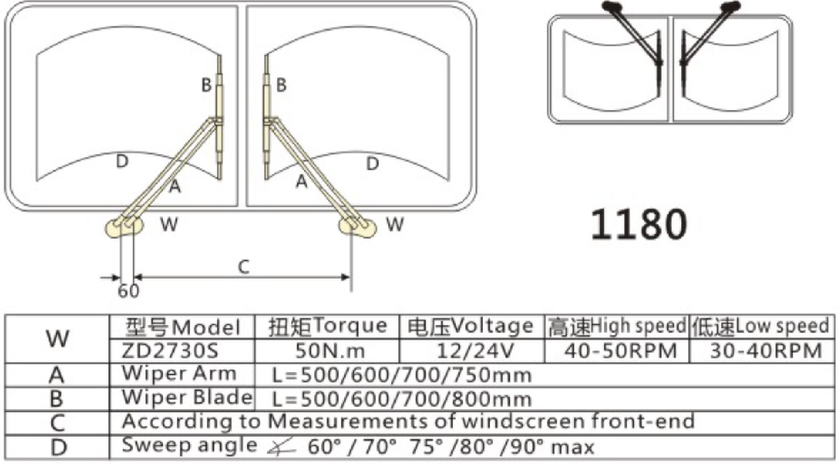

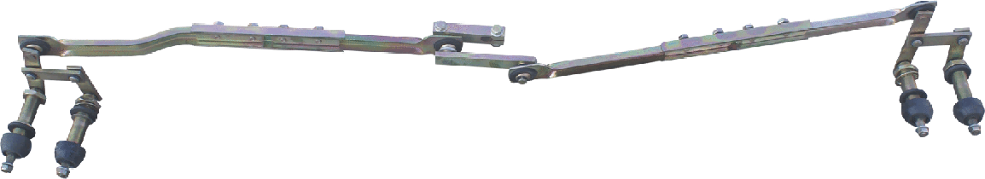

**Channel steel along scraping linkage**

Suitable for minibuses, heavy trucks and other narrow commercial vehicles

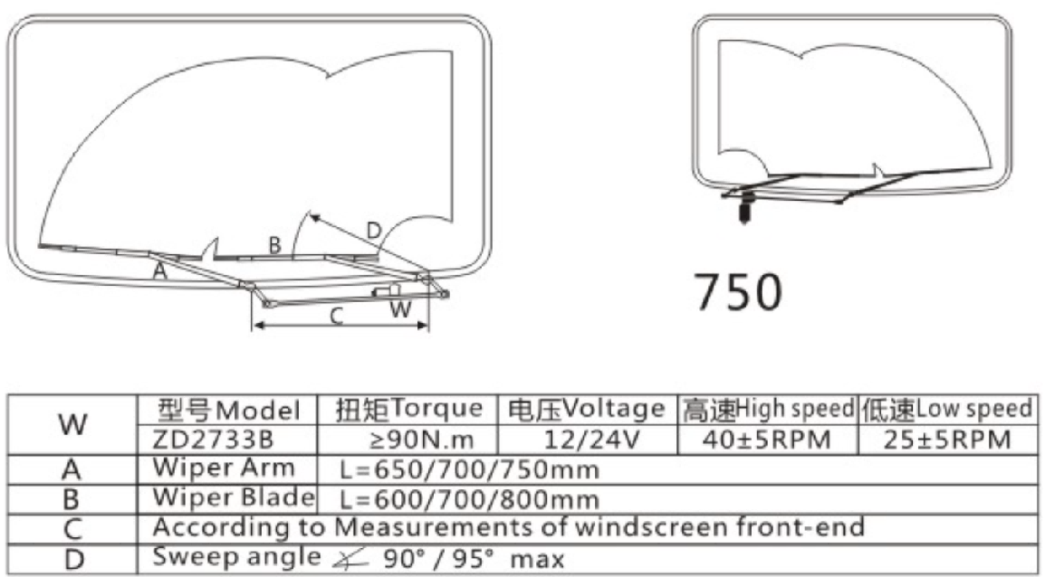

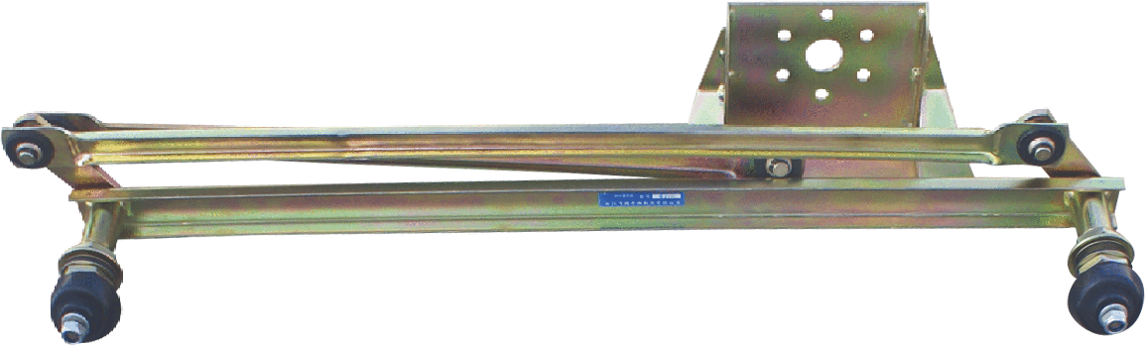

**Single wiper arm linkage**

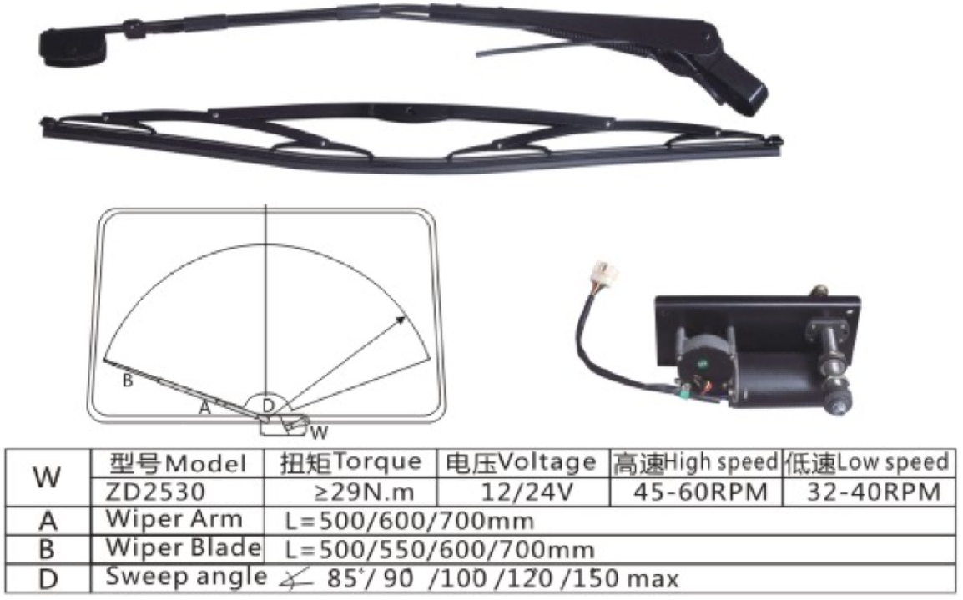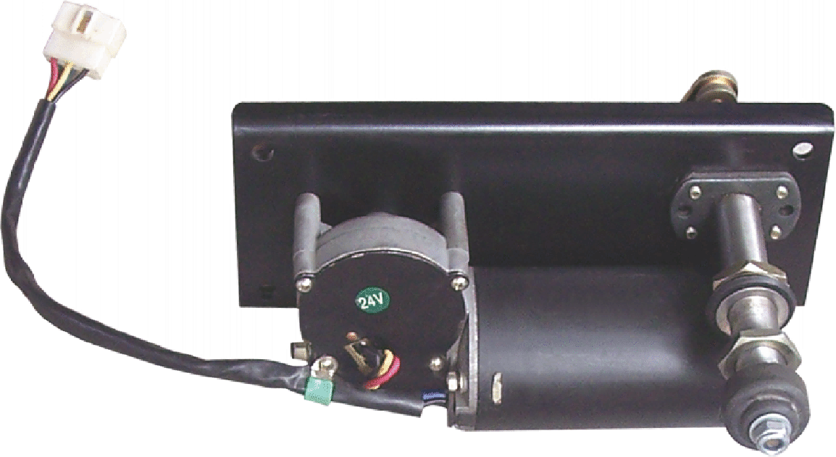

**Double rod scraper arm linkage**

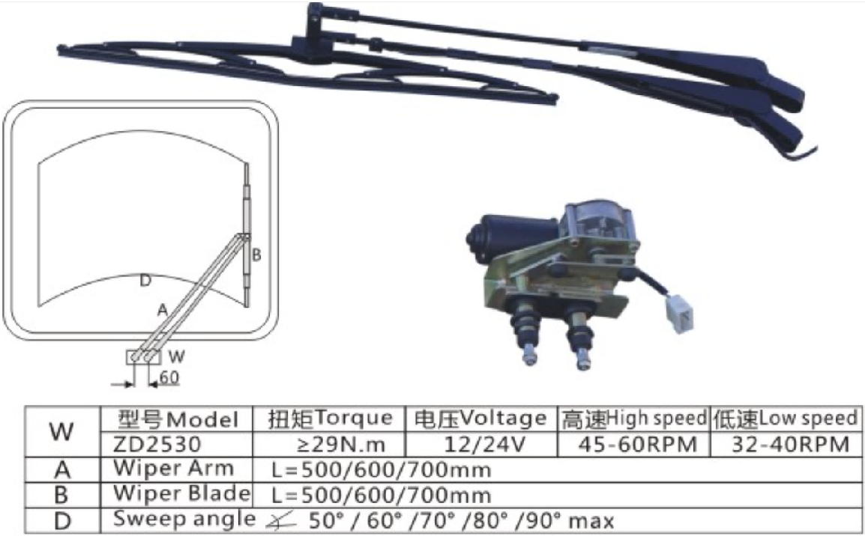

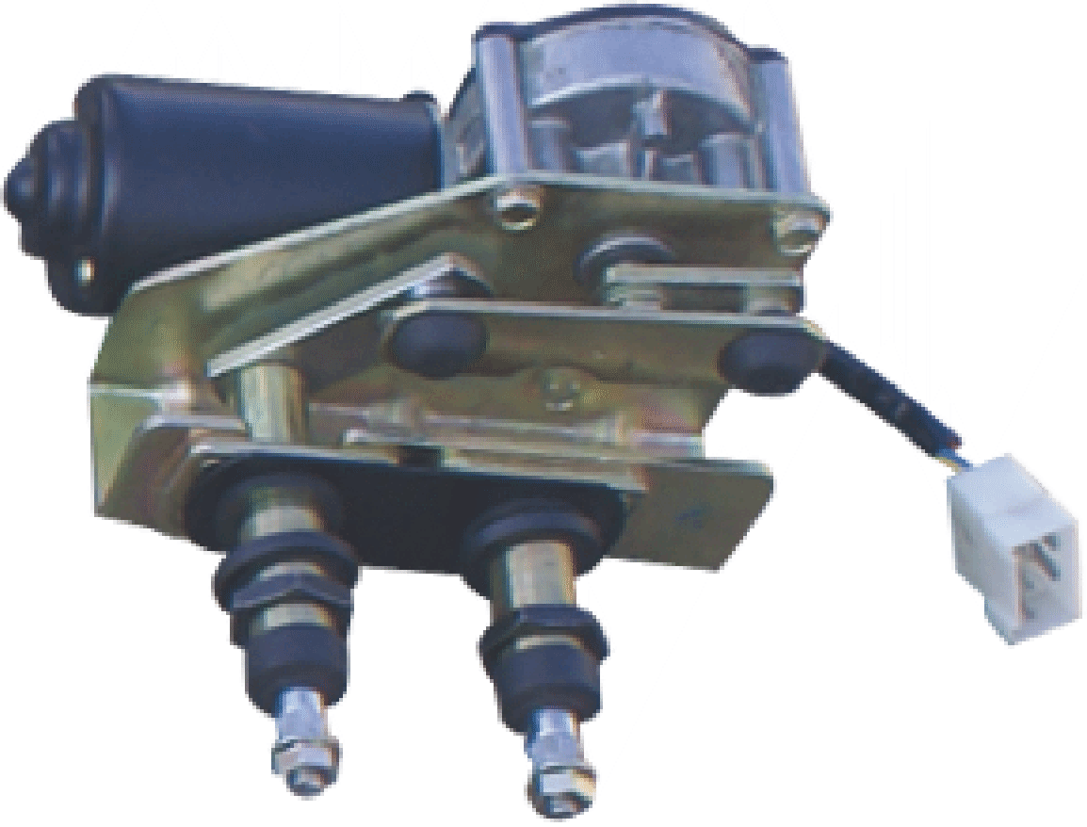

**A0 plan linkage and de motor assembly**

Applicable vehicle model: Shandeka

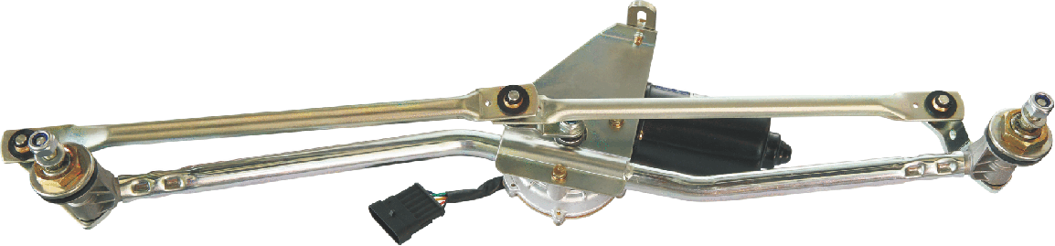

**C7 Wiper linkage and motor assembly**

Applicable vehicle model: Shadeka

