**SINGLE LAMP CONTROLLER**

**PRODUCT MANUAL**

**SZ10-NEMA**

**Update date: 2021-5-11**

**SHANGHAI SHUNCOM AIOT CO., LTD**

**INTRODUCTION**

SZ10-NEMA single lamp controller is developed specially for foreign market demand by SHUNCOM. It is an important part of street lamp control system. The core chip of SZ10-NEMA controller adopts self-developed ZIGBEE wireless communication module. Together with professional hardware and software design, SZ10-NEMA controller offers powerful functions, easy implementation, wiring free, reliable operation and easy-maintenance. With all these advantages, SZ10-NEMA controller is a high performance and energy saving product, specialized for intelligent street lighting.

**COPYRIGHT**

All contents contained in the Manual are protected by Copyright Law. No organization or individual shall copy or reprint the Manual or parts thereof in any forms or means without the written authorization of Shuncom.

The Company reserves the rights to modify, explain and publish the Manual without prior statement.

**Contents**

1. Product Description - 1 -

2. Product Appearance - 3 -

3. Technical Parameters - 4 -

4. Installation Requirements - 5 -

5. Wiring Method - 6 -

6. Disclaimer - 7 -

7. Service and Support - 8 -

1. Product Description

SZ10-NEMA controller conforms to IEEE802.15.4 protocol of ZIGBEE communication standard. It has the advantages of remote communication, strong anti-interference capability and flexible networking, realizing peer-to-peer and peer-to-multi peer transparent data transmission among devices, and constructing star network or mesh network topology. The interface standard is designed by TE Connectivity of ANSI C136.41-2013. Dimmable socket and shrapnel contact are adopted to provide mechanical and electrical interconnection between light control unit and lamps using solid twist lock contacts to achieve reliable power interconnection. It is the ideal choice for outdoor business and public lighting.

SZ10-NEMA single-lamp controller consists of a current and voltage measurement circuit, which collect real-time load performance and power consumption of single-lamp controller. It helps to largely reduce work load of street lamp management department, and improve working efficiency, therefore significantly improve energy-saving benefit of all society.

**Main Features of SZ10-NEMA single-lamp controller:**

*● Input power: AC 110~277V 50/60H.*

*● Output power：AC 110~277V 50/60H*

*● Measuring Current, Voltage, Power; Power Consumption detection function.*

*● One way switch and Dali or 0～10V or PWM dimming signal output.*

*● Monitor the working status of lamps and lanterns, anomaly outputs alarm.*

*● Single lamp custom group control.*

*● Local timing, latitude and longitude control functions.*

*● Over-current protection, lamps condition detection and default lighting functions.*

*● Switch and dimming controls suitable for various types of lamps, such as LED lamp, high voltage sodium lamp, metal halide lamp, etc.*

*● Overload protection design for ensuring security.*

*● Radio frequency: Global free frequency band of 2.4G ISM*

*● Number of wireless channels: 16*

*● Single network capacity: 65535 nodes.*

*● Through communication protocol of ZIGBEE wireless networking.*

*● Industrial operating temperature range: -40 °C ~ +85 °C*

*● Easy and simple installation, can respond to the instructions sent by the center in seconds.*

1. Product Appearance

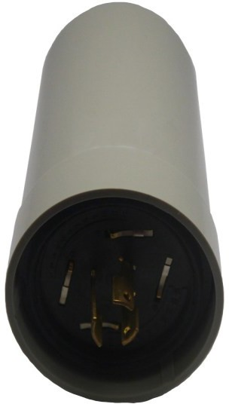 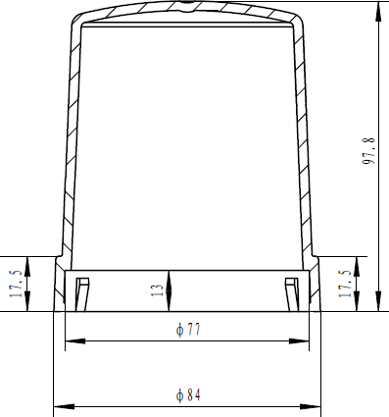

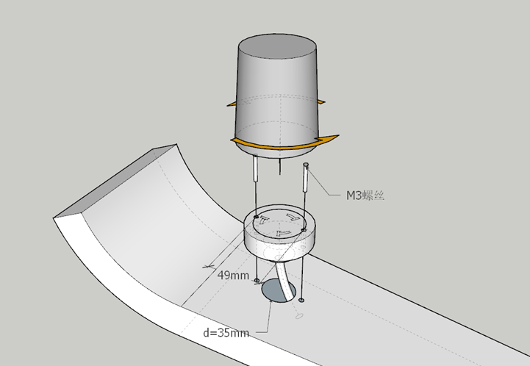

1. Technical Parameters

|  |  |  |  |
| --- | --- | --- | --- |
| **No** | **Item** | **Parameter value** | **Remarks** |
| **1** | Relay Parameter | 250V/16A (1 route) |  |
| **2** | Dimensions | Φ84 x 97.8 (mm) |  |
| **3** | IP Code | IP65 | IP66 optional |
| **4** | Rated Output Current | 4A | 400W Max |
| **5** | Wireless Frequency | 2.4G |  |
| **6** | Dimming Type | Dali/0-10V/PWM | Optional |
| **7** | Transmission Distance | 400 m |  |
| **8** | Product Output | Single-phase AC |  |
| **9** | Data Collection | U, I, P, Q, COSΦ |  |
| **10** | Antenna Frequency Band | 2.4G |  |
| **11** | Antenna Gain | 3DB |  |
| **12** | Antenna VSWR | ≤2.0 |  |
| **13** | Antenna Type | Built-in |  |
| **14** | Protection against high voltage surges | 6kV |  |
| **15** | Protection | Class II |  |
| **16** | Nominal Voltage | 230V |  |

Remarks: Customization possible.

1. Installation Requirements

Rain, positive pole and negative pole connected in a contrary way shall be avoided for the installation and placement of SZ10 series single-lamp controller. Single lamp controller shall be installed fixed, with the scratch and insulation damage of the line avoided.

1. Wiring Method

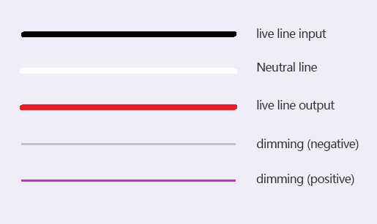

**Black:** live line input

**White:** neutral line

**Red:** live line output

**Gray:** dimming (negative) Dali-

**Purple:** dimming (positive) Dali+

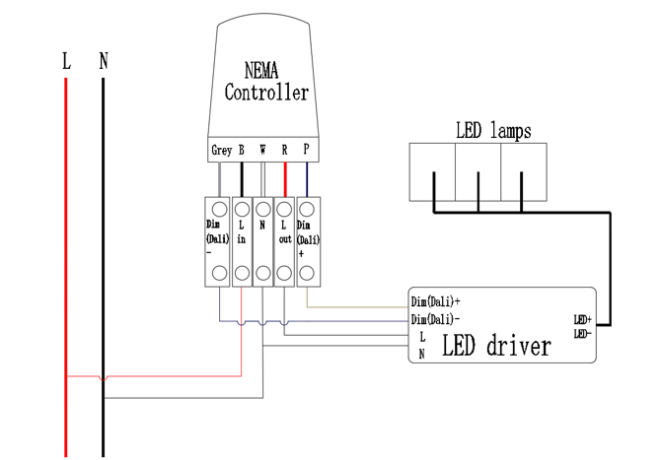

1. Disclaimer

Shuncom shall take no responsibility for not working properly or wrong installation due to violation of this manual or repair and maintenance services provided by non-designated personnel.

Quality guarantee shall be invalid on the day when the enclosure of controller is opened.

1. Service and Support

For any aftersales service or technical supports, please contact our sales team or technical engineers.

**SHANGHAI SHUNCOM AIOT CO., LTD**

TEL: +86(21)-33933988

EMAIL:*8028@shuncom.com*

ADD: 6 /F, No.1 Building, 88 Lane, Sheng Rong Road, Pudong New Area, Shanghai, China