

Ultrasonic Flaw Detector
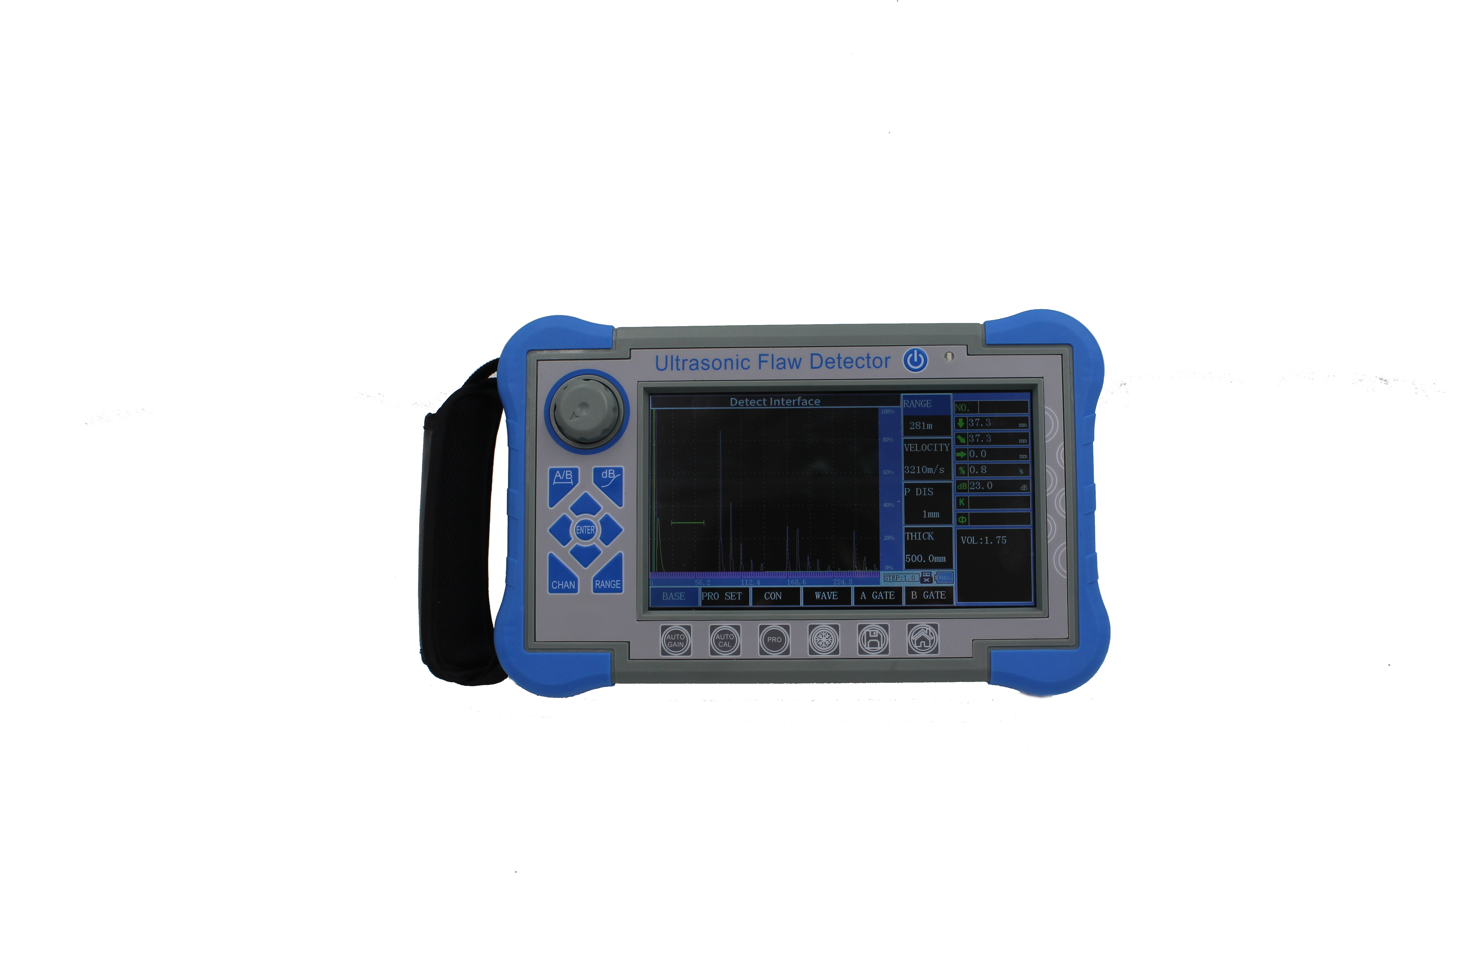
QUAM UT900

A、Introduction

Digital ultrasonic flaw detector is advanced type, which is touch screen, can quickly, easily and without damage, accurately detect, locate, evaluate and diagnose various defects inside the work-piece such as cracks, welds, pores, sand holes, inclusions, folding, etc. It has been applied for electric power, petrochemical, boiler and pressure vessel, steel structure, military, aerospace, railway transportation, automobile, machinery and other fields. It is an essential instrument for the non-destructive testing industry.

B、Features

●High-precision quantification and positioning to meet the requirements of near and far distance detection
●The near-field blind zone is small, can meet the detecting requirements for small-diameter and thin-walled pipe.
●Auto calibration function:one-button auto calibration,easy to operate, automatic test probe “P Delay”,”K value”,”X value” and the velocity
●Automatic display the defect echo position(Depth:d, Horizontal:p,Distance:s, Amplitude,dB,ф )
●Switch three scales freely(Depth:d, Horizontal:p,Distance:s)
●Auto gain, peak envelope, peak memory functions, which can improve the detection efficiency.
●Automatically record the flaw detection process and dynamic playback
●φ value calculation：Forging flaw detection by straight probe, can find the highest wave to conversion φ value automatically
●500 independent channels(can be expandable), which can input and store the detection standards of any industries freely, do not need to carry the standard blocks for on-site inspection.
●Store, playback 500 A-scan waves and data freely
● The DAC, AVG, and TCG curves (depth compensation) are automatically generated and can be segmented. The sampling points are unrestricted and can be corrected and compensated.

●14 built-in inspection standards
●Free to enter any industry standards
●Pulse width and strength can adjustable
●B scan and B color scan function；

●Can communicate with the computer, and export WORD. File, also the detection report

●IP65 ABS plastic case, sturdy and durable,water-proof and dust-proof, and excellent anti-interference ability
●Use (wireless) communication software to analyze data print reports, etc；
●260,000-color true color screen, is suitable for working environment under strong light or low light

●High performance lithium battery, can work continuously for 8-10 hours
●Real-time clock recording: real-time flaw detection date, time tracking record, and storage
●Power-down protection, storage data can not lost
●Flaw detection parameters can be automatically tested or preset
●Digital reject, does not affect gain and linearity
●Gain compensation: Db attenuation can be corrected for surface roughness, curved surfaces, long-range flaw detection of thick work-pieces, etc.

●Can operate the flaw detector by software at the PC, achieving the goal of computer-controlled flaw detector to detecting

C．Technical Specification
Display | 7 inch TFT color screen，800*480 resolution
Operation mode | Button, Rotary, Touch Screen
Power supply | Lithium Ion Battery
Battery capacity | 5.0Ah
Power voltage | 12V
Power quantity | 1
Working time | ≥8 hours
Adapter input | DC100～240V 50Hz/60Hz
Adapter output | AC 12V
Adapter power | 36W
Data storage | SD card(16G)
Alarm | 1
Working Temperature | -10℃～45℃
Storage Temperature | -20℃～60℃
IP Grade | IP65
Dimension | 245*155*55mm
Weight | 1.18kg（included battery）
Conventional UT Model
Probe Connector type | LEMO 00
Channel Type | Single channel
Channel Num | 500 group(able to be scaled)
Pulse Type | Negative sharp wave
Transmit Voltage | 50～350V，step in 50V
Damping | 560Ω
Gain | 0~110dB，step：0.5/2/6/12dB
Gain Fine Adjustment | -4~+4
Surface compensation | All Gain Range
Working Frequency | 0.5~20MHz；
Probe Type | Single，Dual, Through, Immersion type
Filter | Three optional:  1~4MHz/0.5~10MHz/2~20MHz
Detection Mode | Negative/Positive/Two-way/RF
Reject | 0~80%，step 1%
Testing Range | 0~15000mm，Minimum display range:15mm（in steel）
Material Velocity | 100~20000m/s
Pulse displacement | -10~1000mm
P DELAY | 0~200us
X-VAL | 0~100mm
Guide | Weld, Sheet, Forging inspection
Testing Point | Peak/X-val/J val
Measurement | Gate：Amplitude、Amplitude dB value、Range、Horizontal distance、Vertical distance、The difference value between A and B Gate  Cursor:2 cross cursors, can test the horizontal and vertical distance, and the distance between cursors(under B scan function)
Gate | Gate start:all range
Gate | Gate width:all range
Gate | Gate level：10~90%，step:1%
Curve | DAC, maximum six curves, meet to NB/T 47013,GB/T 11345,GB/T 29712, and other standards
Curve | TCG, maximum six curves
Curve | AVG
Other functions | Full screen, cursor switch(range/Height/Horizon), single/continuous auto gain(10~100%, step 10%), echo compare,echo full, peak envelope,peak memory,fast scan,outside mode,screenshot
Other functions | Peak freeze/Crack depth/Gate expansion//curved surface modification/ B scan/Flat weld simulation//video
Alarm | Sound and light alarm
Sensitivity Leavings | ≥65dB(200mm—Φ2FH,2.5PΦ20)
Horizontal linearity error | ≤0.3%
Vertical linearity error | ≤3%
Amplitude linearity error | ≤±2%
Attenuator accuracy | 20dB ±1 dB
Dynamic range | ≥32dB
Distant resolution | ≥26dB
Noise Level | ＜40×10⁻⁹ V/

D、Standard Configuration

 | Name | QTY
1 | Main unit | 1
2 | Power adaptor | 1
3 | probe connecting cable | 2
4 | Instrument case | 1
5 | Instruction manual | 1
6 | Straight probe 10mm 2.5MHz | 1
7 | Angle probe 13x13 K2 2.5MHz | 1
8 | Warranty card | 1
ASIA TRINITY ENTERPRISES LIMITED
Address: Rm.1405.1407, Tianle Building, 1021 Buji Road, LoHu, Shenzhen.
Tel： (86) 0755-2394-2087
Fox：(86) 0755-2390-7646
Mail：info@asiatrinity.com
Web：www.quamtec.com

